Worlds of Words
Korean Culture & Language Book Kit
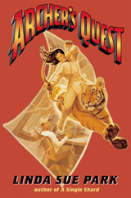
Archer's Quest.Park, L. S. (2006). New York: Clarion Books. ISBN: 9780618596317
Twelve-year-old Kevin Kim helps Chu-Mong, a legendary king of ancient Korea, return to his own time. Kevin Kim is a typical contemporary American boy who struggles to view himself as Korean. His character is presented differently from the majority of Korean-American characters in children’s book who typically are presented as newly immigrated families to the States.
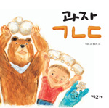

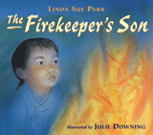
Cookie, ㄱㄴㄷ ( korean alphabet book). Park, S. C. (2006). Cookie, ㄱㄴㄷ ( korean alphabet book). Seoul: Yeo Woo Goh Gae publisher. ISBN: 9780618596317
The process of making cookies teaches how to make the Korean alphabet, Hangul. The cookie dough makes different shapes that look like the Korean alphabet.
The Firekeeper'sSson. Park, L. S. (2004). New York: Clarion Books. ISBN: 9780618133376
In early-19th-century Korea, after Sang-hee's father injures his ankle, Sang-hee attempts to take over the task of lighting the evening fire, which signals to the palace that all is well. Includes historical notes.

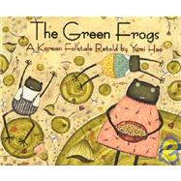
The Green Frogs: A Korean Folktale Retold. Heo, Y. (1996). Boston: Houghton Mifflin Company. ISBN: 978-0618432288
A folktale about two green frogs who always disobey their mother explains why green frogs cry out whenever it rains. This folktale is one of the most popular stories told by parents in Korea. The life-long disobedient green frogs concern their mother. She is afraid that her children will do the opposite from what she asks for her grave, so she asks them to bury her near the river hoping they will bury her in the hill. The frogs choose to follow their mother’s last wish. The mother’s grave is near the river, so the frogs cry whenever it rains, worrying that the rain will demolish the grave. That’s why a frog’s cry gets louder when it rains.
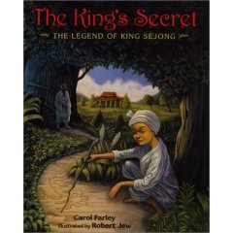
King's Secret: The Legend of King Sejong.Farley, C., & illustrated Cooper, F. (1995). New York: Lee & Shepard Books. ISBN: 978-0688127763
Chosun Dynasty had a wise King Sejong who ruled the great land of Korea. When a humble servant boy tells of his longing to read and write, King Sejong sets out to create a simple yet beautiful way to write the Korean language. The people reject the new way of writing--until the servant boy gives the king another grand idea.

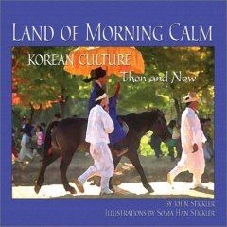
Land of morning calm: Korean culture then and now. Stickler, J. (2003). Fremont, CA: Shen's Books. ISBN: 978-1885008220
Introduces the cultures and traditions of Korea, from ancient times to the present. The illustrations and photos provide a brief introduction to Korean culture.

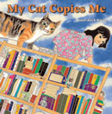
My cat copies me (English edition). Kwon, Y. (2007). La Jolla, CA: Kane/Miller. ISBN: 978-1-933605-26-5
This book explores the special bond between children and their pets as a little girl and her cat play, hide, and comfort one another. The illustrator, Kwon, studied advertisement art and now lives in China studying Eastern Art with her husband who studies Eastern philosophy. Korean Edition is available.
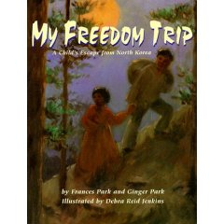

My freedom trip.Park, F., & Park, G. (1998). Honesdale, Pennsylvania: Boyds Millls Press, Inc. ISBN: 978-1563974687
Based on the life of the authors' mother, this is the story of her escape from North Korea after the communist take-over. Stories of escapes from North Korean are not a common topic in children’s literature in South Korea, thus, the availability of the book is more valuable.
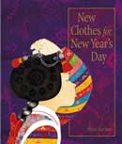
New clothes for New Year's Day. Bae, H. (2007). La Jolla, CA: Kane Miller Book Publishers. ISBN: 978-1-933605-29-6
This informational book explains the steps to wearing special new clothes for New Year's Day (Sol-bim). The illustrations are detailed, so that the process of putting on a Korean Han Bok for New Year’s Day is well described. Korean edition is available.

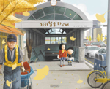
No way subway. Ko, T, Y. & Kim, Y. J. (2006). Kyung Gi Doh, Pajoo city: Gil Buht. ISBN: 9788955820461
A little boy and his older sister ride a subway to go to their grandparents' house. It's their first time to ride a train without a grown-up. The big sister feels so much responsibility, yet the baby brother doesn’t listen to her. His impulsive behavior worries his big sister. After they arrive in their granny’s house, the sister bursts with her tension. The dramatic illustrations appeal to young children.
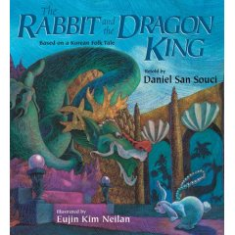
The Rabbit and the Dragon King: Based on Korean Folklore. Neilan, E. K. (2002). Honesdale, Pennsylvania: Boyds Mills Press, Inc. ISBN: 978-1590784181
Thanks to a quick-witted rabbit and a seaworthy turtle, an ill dragon king regains his desire to live. This is one of the most popular folktales in Korea. Dragons are not as big in Korea as in Chinese culture, yet the dragon figure is often associated with the King of the ocean.

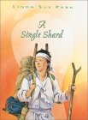
A single shard. Park, L. S. (2001). New York: Clarion Publisher. ISBN: 978-0395978276
Linda Sue Park's 2002 Newbery Award-winning story. Tree-ear, an orphan, lives under a bridge in Ch'ulp'o, a potters' village famed for delicate celadon ware. Tree-ear is fascinated with the potter's craft; he wants nothing more than to watch master potter Min at work, and he dreams of making a pot of his own someday. When Min takes Tree-ear on as his helper, Tree-ear is elated -- until he finds obstacles in his path: the backbreaking labor of digging and hauling clay, Min's irascible temper, and his own ignorance. But Tree-ear is determined to prove himself -- even if it means taking a long, solitary journey on foot to present Min's work in the hope of a royal commission . . . even if it means arriving at the royal court with nothing to show but a single celadon shard.
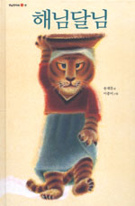
Sun and moon. Song, J., & Lee, J. (2004). Pah Joo, Kyung Gi Doh, Korea: Goohk Min Suh Gwan. ISBN: 9788911023639
This Korean version of the Red Riding Hood story is a pourquoi for the sun and moon creation. The boy and girl become the sun and the moon after the life-threatening tiger is killed. The tiger is as greedy as the wolf in the western version of Red Riding Hood. The mother becomes the first victim as Red Riding Hood's grandma is swallowed by the wolf. There are many versions of Sun & Moon folklores in Korea, yet this version is often praised as the best picture book presentation of the story.

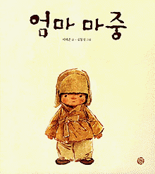
Waiting for moma. Lee, T. J. (2007). North-South. ISBN: 9780735821439 (bilingual Korean/English edition)
This is the simple story of a young boy waiting at a tram-stop for his mother. Trams come and go, people get on and get off, yet the boy waits patiently, even as a snowstorm gathers. Winner of Korea's prestigious Baeksang Publishing Award for children's literature, and selected as Book of the Year by three of Korea's national newspapers. Author Tae-Jun Lee was born in Korea in 1904 and was orphaned as a child. He wrote his most famous short stories during the 1930s, including 'Waiting for Mama' in 1938. His works are well-loved in Korea for their poetic prose and emotional sensitivity. Lee was later a war correspondent during the Korean War. This edition with new illustrations was published almost half a century after his death.
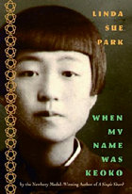
When my name was Keoko. Park, L. S. (2002). New York: Clarion Books. ISBN: 978-0440419440
With national pride and occasional fear, a brother and sister face the increasingly oppressive occupation of Korea by Japan during World War II, which threatens to suppress Korean culture entirely. The fact that Korea was colonized by Japan during World War II is not well known in the United States. This book broadens the historical context around World War II and also helps to develop cultural awareness through two Korean protagonists who resist taking on Japanese identity. Korean culture is well illustrated through the strong gender and family relationship hierarchy, social oppression, acceptance, sibling dynamics, and cultural identity.

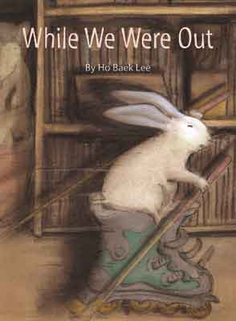
While we were out. Lee, H. B. (2003). La Jolla, CA: Kane/Miller. ISBN: 978-1-929132-44-7
The patio door is left unlocked. The rabbit explores room after room, picking up this and looking at that. The adorable rabbit exhausts herself and her curiosity before the family returns. Lee studied Industrial Design and Journalism in Korea and Communication & Images in Paris. Korean edition is available.
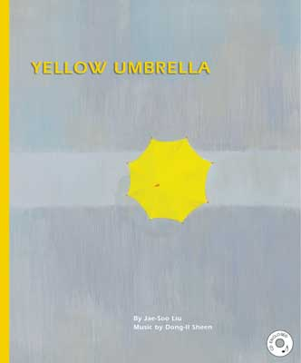
Yellow umbrella ( English edition). Liu, J., & Sheen, D. I. (2002). Kane/Miller Book Publisher. ISBN 978-1-929132-36-2
This wordless book presents a birds-eye view of colorful umbrellas carried by children on a rainy walk to school. Originally published in South Korea with a 15 track of music CD attached to the book. Liu studied Oil Painting in college & graduate school and now teaches picture books in Seoul City University. Sheen majored in Composition in Korea and New York University.
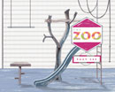
The zoo (1st ed.). Lee, S. (2007). La Jolla: Kane/Miller. ISBN: 978-1-933605-28-9
A little girl's trip to the zoo becomes an extraordinary, imaginative, fun-filled animal adventure. Meanwhile, her parents experience an alarming adventure of their own. Suzy Lee is an artist and illustrator, born in Seoul, Korea. She received her BFA in painting from Seoul National University and her MA in Book Arts from Camberwell College of Arts, London. Her books and paintings have won numerous international awards and have been featured in exhibitions worldwide including Bologna Children’s Book Exhibition.

