
A Movie in My Pillow / Una película en mi almohada
Jorge Argueta, Elizabeth Gomez
Lee & Low Books Pub Date: 4/1/2013

A Song for Cambodia
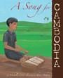
Michelle Lord, Shino Arihara Lee & Low Books
Pub Date: 3/1/2008

Amelia's Road
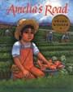
Linda J. Altman, Enrique O. Sanchez
Lee & Low Books Pub Date: 9/1/1993

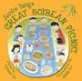
Auntie Yang's Great Soybean Picnic
Ginnie Lo, Beth Lo Lee & Low Books
Pub Date: 11/1/2017

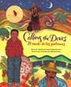
Calling the Doves / El canto de las palomas
Juan Felipe Herrera, Elly Simmons
Lee & Low Books Pub Date: 4/1/2014

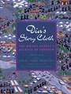
Dia's Story Cloth
Dia Cha, Chue Cha, Nhia Thao Cha
Lee & Low Books Pub Date: 4/1/1996

Boy, Everywhere

A. M. Dassu
Lee & Low Books
Pub Date: 4/20/2021

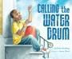
Calling the Water Drum
LaTisha Redding, Aaron Boyd
Lee & Low Books Pub Date: 2/8/2022

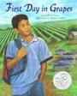
First Day in Grapes
L. King Perez, Robert Casilla Lee & Low Books
Pub Date: 9/1/2014

Brothers in Hope
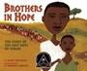
Mary Williams, R. Gregory Christie
Lee & Low Books Pub Date: 4/1/2013

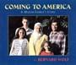
Coming to America
Bernard Wolf
Pub Date: 5/1/2002

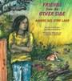
Friends from the Other Side / Amigos del otro lado
Gloria Anzaldúa, Consuelo Mendez
Lee & Low Books Pub Date: 6/3/1997

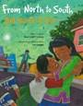
From North to South / Del Norte al Sur
René Colato Laínez, Joe Cepeda
Lee & Low Books Pub Date: 5/1/2014

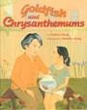
Goldfish and Chrysanthemums
James Cheng, Michelle Chang
Lee & Low Books Pub Date: 4/1/2003

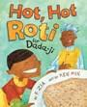
Hot, Hot Roti for Dada-ji
Farhana Zia, Ken Min
Lee & Low Books Pub Date: 3/1/2017

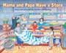
Mama and Papa Have a Store
Amelia Lau Carling Lee & Low Books
Pub Date: 10/1/2016

Ghosts for Breakfast

Stanley Todd Terasaki, Shelly Shinjo
Lee & Low Books Pub Date: 3/1/2017

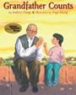
Grandfather Counts James Cheng, Ange Zhang Lee & Low Books
Pub Date: 9/1/2000

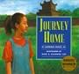
Journey Home
Lawrence McKay Jr., Dom Lee, Keunhee Lee
Lee & Low Books Pub Date: 4/1/1998

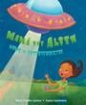
Mamá the Alien / Mamá la extraterrestre
René Colato Laínez, Laura Lacámara
Lee & Low Books Pub Date: 5/1/2016

Going Home, Coming Home
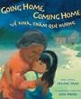
Truong Tran, Ann Phong Lee & Low Books
Pub Date: 4/1/2014

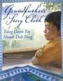
Grandfather's Story Cloth
Linda A. Gerdner, Sarah Langford, Stuart Loughridge
Lee & Low Books Pub Date: 5/1/2015

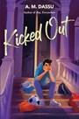
Kicked Out
A. M. Dassu
Lee & Low Books
Pub Date: 4/23/2024

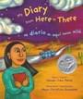
My Diary from Here to There / Mi diario de aqui hasta allá
Amada Irma Perez, Maya Gonzalez
Lee & Low Books Pub Date: 4/1/2013

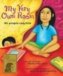
My Very Own Room / Mi propio cuartito
Amada Irma Perez, Maya Gonzalez
Lee & Low Books Pub Date: 4/1/2013

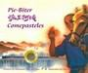
Pie-Biter
Ruthanne Lum McCunn Lee & Low Books
Pub Date: 2/15/2016

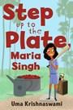
Step Up to the Plate, Maria Singh
Uma Krishnaswami, Nidhi Chanani
Lee & Low Books
Pub Date: 5/15/2017

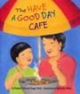
The Have a Good Day Café
Frances Park, Ginger Park, Katherine Potter
Lee & Low Books Pub Date: 5/1/2002

Passage to Freedom
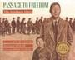
Ken Mochizuki, Dom Lee Lee & Low Books
Pub Date: 5/1/1997

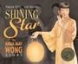
Shining Star
Paula Yoo, Lin Wang
Lee & Low Books Pub Date: 6/1/2009

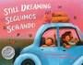
Still Dreaming / Seguimos soñando
Claudia Guadalupe Martínez, Magdalena Mora, Luis Humberto Crosthwaite
Lee & Low Books
Pub Date: 10/11/2022

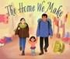
The Home We Make
Maham Khwaja, Daby Zainab Faidhi
Lee & Low Books
Pub Date: 10/8/2024

Pedro's Yo-Yos
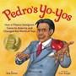
Rob Peñas, Carl Angel Lee & Low Books
Pub Date: 4/30/2024

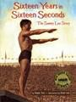
Sixteen Years in Sixteen Seconds
Paula Yoo, Dom Lee
Lee & Low Books Pub Date: 4/1/2005

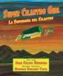
Super Cilantro Girl / La superniña del cilantro
Juan Felipe Herrera, Honorio Robledo Tapia
Lee & Low Books
Pub Date: 1/11/2022


The Story of Anna May Wong
Paula Yoo, Lin Wang
Lee & Low Books Pub Date: 1/8/2019

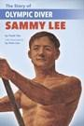
The Story of Olympic Diver Sammy Lee
Paula Yoo, Dom Lee Lee & Low Books
Pub Date: 2/25/2020

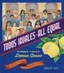
Todos Iguales / All Equal
Christy Hale
Lee & Low Books
Pub Date: 8/13/2019

The Storyteller's Candle / La velita de los cuentos
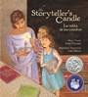
Lucia Gonzalez, Lulu Delacre Lee & Low Books
Pub Date: 4/1/2013

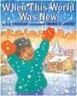
When This World Was New
Danilo Figueredo, Enrique O. Sanchez
Lee & Low Books Pub Date: 5/1/1999

The Upside Down Boy
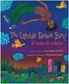
/ El niño de cabeza
Juan Felipe Herrera, Elizabeth Gomez
Lee & Low Books Pub Date: 4/1/2013

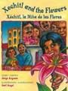
Xochitl and the Flowers / Xóchitl, la Niña de las Flores
Jorge Argueta, Carl Angel Lee & Low Books
Pub Date: 4/1/2013

